Final UMl Diagram

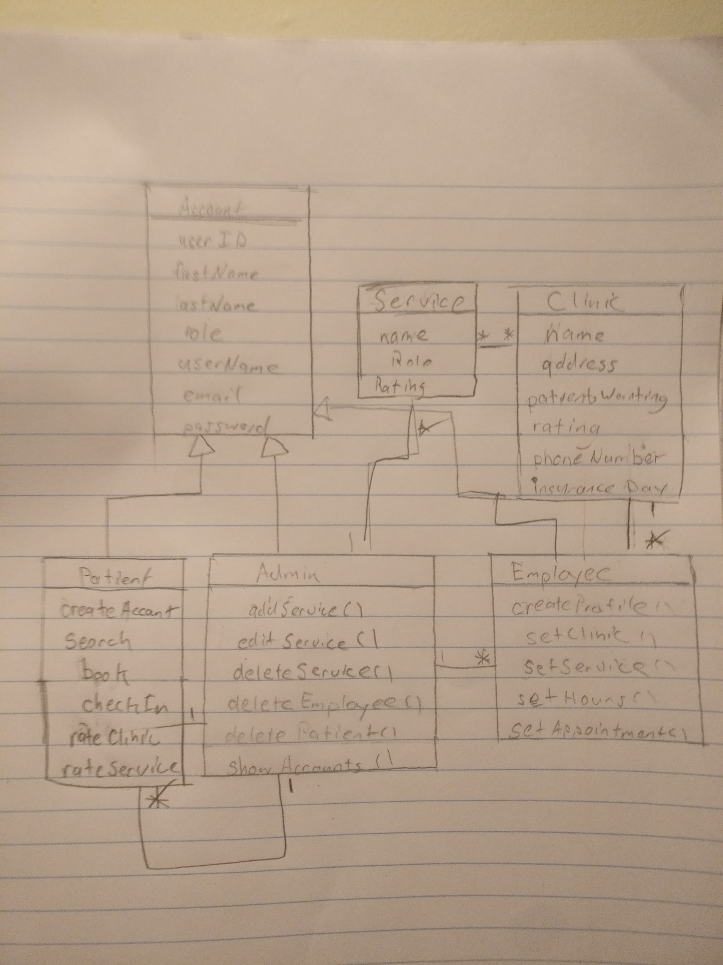

Lessons Learned

* Cultivated the skills and knowledge required to operate Android Studio.
* Learn to develop apps and projects.
* Synchronize data using Firebase.
* Need to stick to an architecture for the app.

Contributions

Deliverable 1

|  |  |  |
| --- | --- | --- |
| Name | Contributions | Comments |
|  |  |  |
|  |  |  |
| Thinh Hong |  |  |
|  |  |  |

Deliverable 2

|  |  |  |
| --- | --- | --- |
| Name | Contributions | Comments |
|  |  |  |
|  |  |  |
| Thinh Hong | Finished UMl Diagram |  |
|  |  |  |

Deliverable 3

|  |  |  |
| --- | --- | --- |
| Name | Contributions | Comments |
|  |  |  |
|  |  |  |
| Thinh Hong | Finished UMl Diagram |  |
| Matt Ignaczak | UI & fixed some build dependencies |  |

Deliverable 4

|  |  |  |
| --- | --- | --- |
| Name | Contributions | Comments |
| Matt Ignaczak | Moved app to MVVM architecture, did dev work on deliverable 4 |  |
|  |  |  |
| Thinh Hong | Finished UMl Diagram, Did part of deliverable 4 |  |
|  |  |  |

Screenshoots